Senior Infants Homework – Week beginning the 17th of October, 2016

Notes or reminders:
Senior Infants A have their last swimming lesson today.
Many thanks to everyone who was able to come to the Curragh Pool over the last few weeks.
We are continuing with this month’s Aistear theme on animals and vets – if you have some dry recyclables for junk art animals please send them in.
Just a reminder that there is no school this Thursday, the 20th of October for an in-service day.
Project work  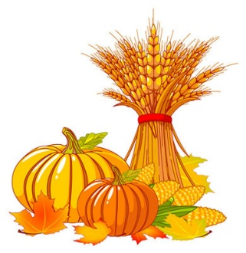 | It’s Autumn  For this week’s project we would like you to choose to do something linked to the season of Autumn. For example, you could go pumpkin shopping, help carve a pumpkin, do a leaf print, design a scarecrow, play conkers, paint some acorns or draw/paint/create an autumn scene…  We really appreciate your support with these projects, please don’t hesitate to get in touch if you have any questions at all.
Reading | Please practice reading the word list found on the back of this sheet every evening. We will be collecting your homework folders back on Friday.
Spelling Words: (words ending in and ip)
win, fin, bin, tin, sip, tip, lip, zip,
Tricky words of the week:
is , you
Sounds of the week:
z, w, ng, v, oo, OO

(little oo eg. cook, book - long OO eg. moon, soon)

Word list:
hat
wet
zip
cat
buzz
ring
long
van
look
cling
soon

