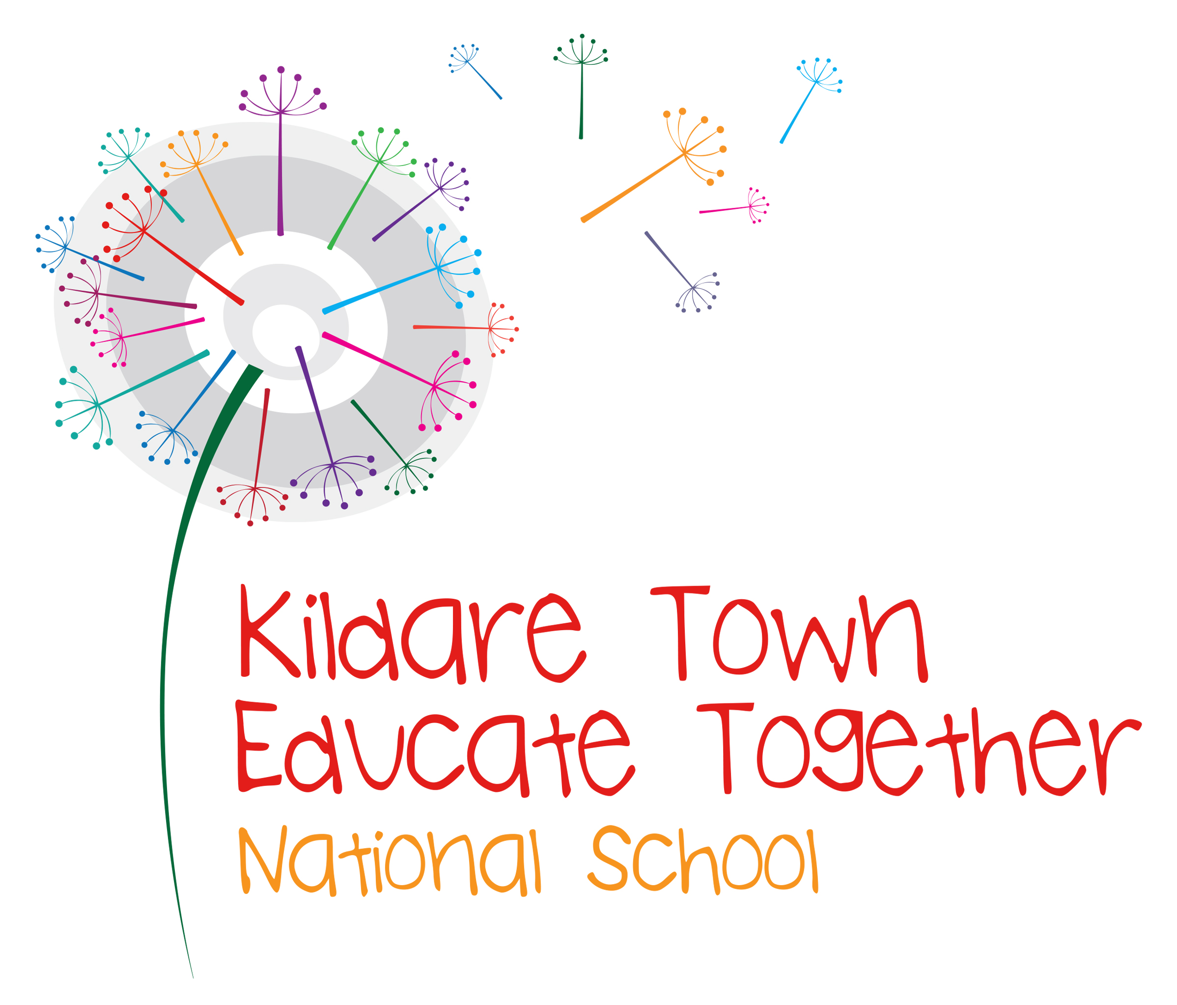

Kildare Town Educate Together NS

Tower View, Kildare Town

20403K

School Self-Evaluation Report

Evaluation period: 09/14 – 06/15

Report issue date: June 2015

School Self-Evaluation Report

1. Introduction

  - The focus of the evaluation

This school self self-evaluation report reflects a review of teaching and learning within the area of Mathematics in Kildare Town Educate Together NS. This evaluation was undertaken during the period (09/14) to (06/15).

This is a report on the findings of the evaluation.

  - School context

We are a new school which opened its doors in August 2012. We opened with 17 children in Junior Infants and 3 children in Senior Infants. This made the school self evaluation task a more complex one. As a new school we were unable to look back at patterns of results and as a Junior school at the time, we were unable to carry out many of the recommended assessments. The school currently has 94 pupils, with 10 children in 2nd class representing the oldest class in the school.

This report is based on Sigma T assessments, seasonal Mathematics assessments and staff reflections on own practice and observations of children’s learning.

Special Class
We have a class for children with Autism in the school. There are 6 children in the class with 2.5 SNAs and a teacher. They have been exempt from the research into standards in the school. There are varying levels of literacy and numeracy in the class. They are being assessed on a regular basis and work off IEPs.

2. The findings

Indicate the quality of practice in relation to the aspects of teaching and learning evaluated with reference to the sub-themes below where relevant.

- Numeracy
It is observed that the children are working at a level above where they should be in the curriculum guidelines. At infant level, they are able to recognise and use numbers and perform simple additions and subtraction calculations.

The average STEN score for both 1st and 2nd class pupils is 6.
60% of children in 1st and 2nd class achieved a STEN of 7 or higher. Only 1 child is below the 30th percentile.

The following table reflects the percentage of correct answers in each of the following skills from standardised testing in October 2014.
 | Understanding Concepts & Facts | Performing Computations & Procedures | Solving Word Problems
1st Class | 64 | 58 | 44
2nd Class | 84 | 73 | 44

Staff reported that while they do provide children with opportunities to experience problem solving, there is a need to become more aware of pupils’ individual problem solving abilities.

- Attainment of curriculum objectives
Overall attainment is above average as outlined in termly assessments and in the standardised testing (Sigma T).
- Pupils’ engagement in learning
It is felt by the staff and by the children themselves that engagement in learning is very high. All children reported to enjoy learning and staff felt that most children were engaged with learning (albeit at different levels).
- Learning to learn
- Preparation for teaching
Staff were prepared with the use of fortnightly plans. Plans were informed by assessment and were driven by a child-centred approach to differentiation. The learning objectives and desired outcomes were also central to planning. The provision of a range of specific problem solving resources would allow for a more widespread engagement with the teaching of problem solving as a skill in a more structured manner.
- Teaching approaches
A range of teaching approaches are used to engage the children and ensure they become active participants in their own learning. This again is a very child-centred approach to planning.
- Management of pupils
As per our code of behaviour children are managed in a positive affirming way. They are taught to be self driven from the outset and be independent thinkers. They are taught in an active way and teamwork is encouraged if possible to ensure high levels of cooperation and engagement in their learning, including the use of paired and group discussion through problem solving and in discussion of mathematical processes.
- Assessment
Assessment folders are kept in all classrooms. They are used to record attainment and most importantly to guide planning and build a picture over time of a child’s progress and achievement in learning across the curriculum. Each teacher uses the information gathered to identify and celebrate the child’s current learning in order to provide him/her with appropriate support in future planning.

3. Progress made on previously-identified improvement targets

- N/A as this is our first evaluation in the area of Mathematics

4. Summary of school self-evaluation findings

4.1 Our school has strengths in the following areas of Mathematics:

- Children generally display high levels of mathematical attainment across all strands in standardised testing
- Children at infant level have a strong understanding of number and mathematical concepts
- Children display positive attitudes towards Mathematics
- Teachers report that pupils at all class levels enjoy problem solving

4.2 The following areas are prioritised for improvement:

(Specify the aspects of teaching and learning that need to be improved)

Using evidence from Sigma T test results and teacher observations, problem solving was identified as an area to be prioritised for improvement. Within problem solving, the following were noted:

- Problem Solving - There is a need identified to explicitly include problem solving in weekly Mathematics lessons. This will include the teaching of a variety of strategies to tackle problem solving and exposing children to a wide variety of problem solving opportunities, including open-ended tasks, games, puzzles and ICT resources.
- Problem Solving & Oral Language - Staff reported the discussion of how children got their answers to problems as an area of need. This ties in with our SSE literacy focus area of oral language.

4.3 The following legislative and regulatory requirements need to be addressed:
(Specify the aspects that need to be addressed)

- Circular on SSE

Appendix to School Self-Evaluation Report:
Legislative and regulatory checklist

Issue | Relevant legislation, rule or circular |  |  |  | Is the school fully meeting the requirements of the relevant legislation, rule or circular? | If no, indicate aspects to be developed
Time in school  - Length of school year - minimum of 183 days  - Length of school day  4 hours 40 minutes (infants);  5 hour 40 minutes (1st-6th classes) | Circular 11/95 |  |  |  | Yes No  Yes No
Arrangements for parent/ teacher and staff meetings | Circular 14/04 |  |  |  | Yes No
Implementation of Croke Park agreement regarding additional time requirement | Circular 0008/2011 |  |  |  | Yes No
Standardisation of school year | Circular 034/2011 |  |  |  | Yes No
Valid enrolment of pupils | Section 9(1), 15(2) and 23 Education Act 1998  Sections 20 and 21, Education (Welfare) Act 2000  Rules 55, 64, 108 and 123, Rules for National Schools  Circular P24/02  Staffing Schedule for current school year |  |  |  | Yes No
Retention of pupils | Rule 64 Rules for National Schools  Circular 11/01  Circular 32/03 |  |  |  | Yes No
Development of school plan | Section 21, Education Act 1998 |  |  |  | Yes No | Ongoing process as we are a new and developing school.
Appointments to posts of responsibility | Circular 07/03  Circular 053/2011 |  |  |  | Yes No
Time for literacy and numeracy - assessing and reporting literacy and numeracy achievement | Circular 0056/11 Initial Steps in the Implementation of the National Literacy and Numeracy Strategy |  |  |  | Yes No
Exemption from Irish | Circular 12/96 |  |  |  | Yes No
Implementation of child protection procedures | Circular 0065/2011  Please ensure the following in relation to child protection |  |  |  | Yes No
 | ▪ Number of cases where a report involving a child in the school was submitted by the DLP to the HSE  ▪ Number of cases where a report involving a child in the school was submitted by the DLP to the HSE and the school board of management informed  ▪ Number of cases where the DLP sought advice from the HSE and as a result of this advice, no report was made  ▪ Number of cases where the DLP sought advice from the HSE and as a result of this advice, no report was made and the school board of management informed |  |  | _____  _____  _____  _____
Implementation of complaints procedure as appropriate | Complaints Procedures, Section 28 Education Act  Primary Boards of Management Information Manual November 2007  Please consider the following in relation to complaints |  |  |  | Yes No
 | ▪ Number of formal parental complaints received  ▪ Number of formal complaints processed  ▪ Number of formal complaints not fully processed by the end of this school year |  |  | _____  _____  _____
Refusal to enrol | Section 29 Education Act 1998  Please provide the following information in relation to appeals taken in accordance with Section 29 against the school during this school year |  |  | N/A
 | Number of section 29 cases taken against the school  Number of cases processed at informal stage  Number of cases heard  Number of appeals upheld  Number of appeals dismissed |  | 0  0  0  0  0
Suspension of students | Section 29 Education Act 1998  Please provide the following information in relation to appeals taken in accordance with Section 29 against the school during this school year
 | Number of section 29 cases taken against the school  Number of cases processed at informal stage  Number of cases heard  Number of appeals upheld  Number of appeals dismissed | 0  0  0  0
Expulsion of students | Section 29 Education Act 1998  Please provide the following information in relation to appeals taken in accordance with Section 29 against the school during this school year
 | Number of section 29 cases taken against the school  Number of cases processed at informal stage  Number of cases heard  Number of appeals upheld  Number of appeals dismissed | 0  0  0  0  0

Policy | Source | Has policy been approved by the board of management? | If no, indicate aspects to be  developed.
Enrolment policy | Section (15)(2)(d) Education Act 1998 | Yes No
Code of behaviour including anti-bullying policy | Circular 20/90  DES Guidelines on Countering Bullying Behaviour 1993  NEWB Guidelines  Section 23, Education Welfare Act 2000 | Yes No
Attendance and participation strategy | Section 22 Education Welfare Act 2000  Equal Status Acts 2000-2011 | Yes No
Health and safety statement | Section 20 Health and Safety Act 2005 | Yes No
Data protection | Data Protection Act 1988  Data Protection (Amendment Act) 2003 | Yes No | Need to do this Policy. Not yet started in the school.
Special education needs policy | Education Act 1998  Equal Status Acts 2000- 2011  Education (Welfare) Act 2000  Education for Persons with Special Education Needs Act (EPSEN) 2004  Disability Act 2005 | Yes No | This has been drafted but not yet ratified.
Relationships and sexuality education (RSE) policy | Relationships and Sexuality Education: Policy Guidelines (1997) | Yes No
Child protection policy | Circular 0065/2011 | Yes No
Parents as partners | Circular 24/91 | Yes No | Parental involvement policy to be created.
Public service (Croke Park) agreement – special needs assistants | Circular 71/11 | Yes No | No policy but we are following the guidelines put in place by DES
Other

